Nermin Khalefa

Final Project

Fall, 2018

JAVA_111

CCAC _West Hills

**Description of what my program does:**

The object I choose for my final project is an airplane. With the help of a blueprint, where we store our all of our variables, whether they were private or public. The private variables are variables that only I can control. But the public variables are accessible by anyone. This project displays the statistics of an airplane, with things such as the plane length, current speed, and even wing size. Using methods such as an if/ else statement, Boolean, and a to string, I was able to complete a well-functioning program with all the statistics of my airplane.

**Screen shoots of coding:**

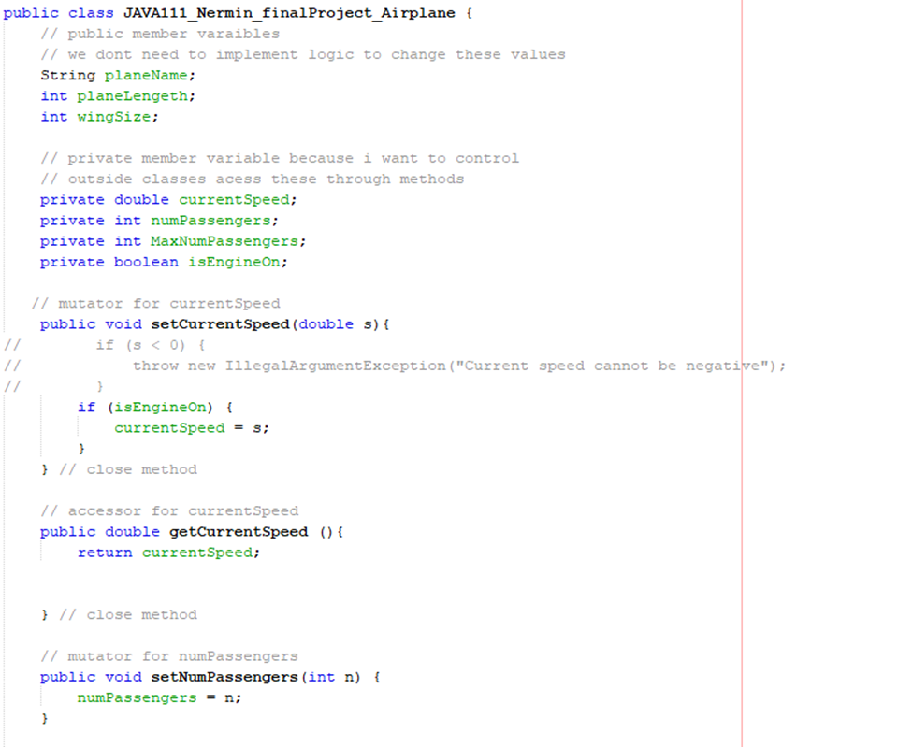

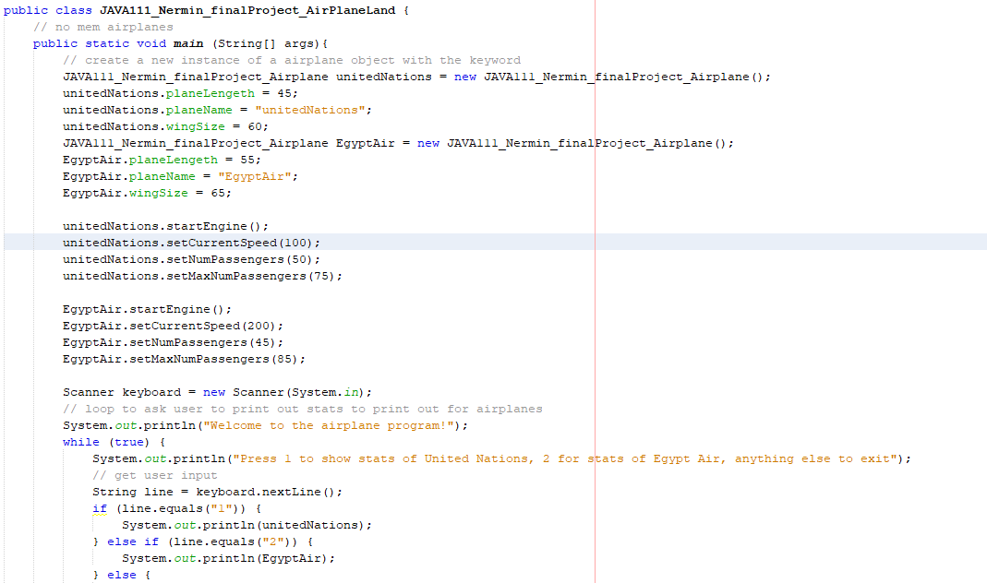

**List of useful learning resources:**

1. <https://www.w3schools.com/js/js_if_else.asp>
2. <https://docs.microsoft.com/en-us/dotnet/visual-basic/programming-guide/language-features/operators-and-expressions/boolean-expressions>
3. <https://www.geeksforgeeks.org/string-in-switch-case-in-java/>

**Description of ideas for future:**

1. What features didn’t you have time to develop?

Some features are more difficult to understand then others but if you put in the effort at home to learn these features, you should have a smooth ride in this class.

1. What components could be made more efficient or clear?

The in class activities really helped to stimulate your brain and clarify how certain coding and features worked, doing such activities more often can really help students to understand lots of concepts.

1. What cool ideas for extension or application do you have?

The whole coding and putting in the effort at home is very helpful, but other cool extensions would include seeing a live version of what you are coding. That is why I really enjoyed the donuts objects that we did, because I was able to fully understand the coding behind the method both visually and mentally. With the ideas of using a string and linking that string to its blueprint, also putting flags on the donuts with its name and size, etc.